**Instructions for installing the Arduino IDE and flashing the firmware**

[ <https://www.arduino.cc/en/Guide/ArduinoNano> ]

1. Download the Arduino IDE from the link below and install the software

<https://www.arduino.cc/en/main/software>

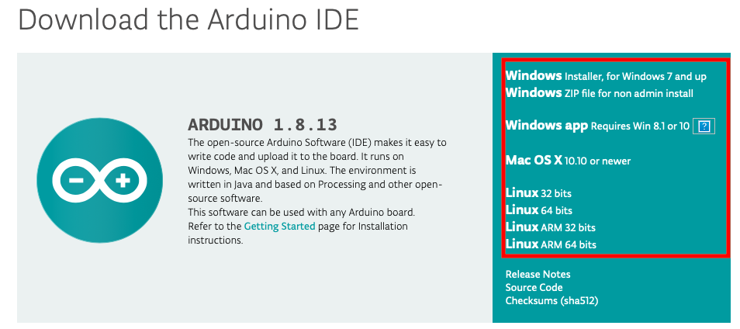

1. Connect the board with the PC(in an USB port)

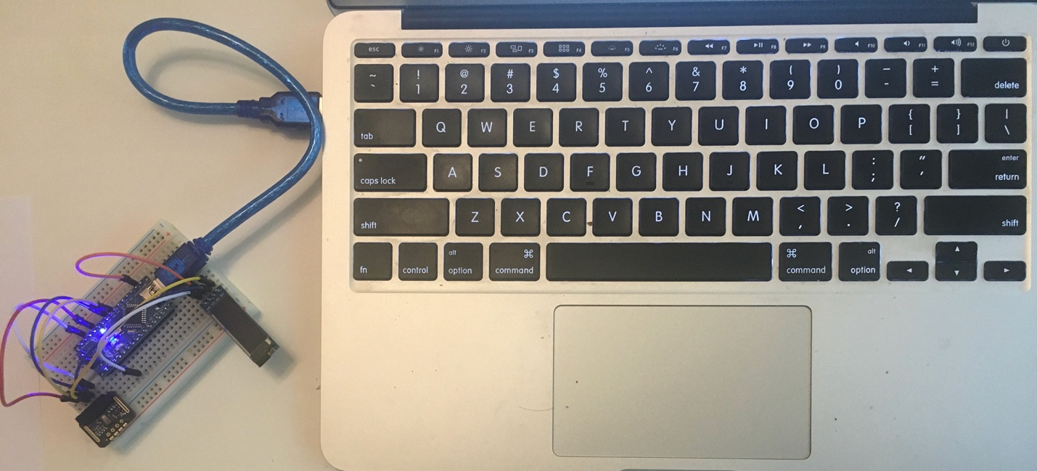

1. Open Arduino IDE and setup the ports.

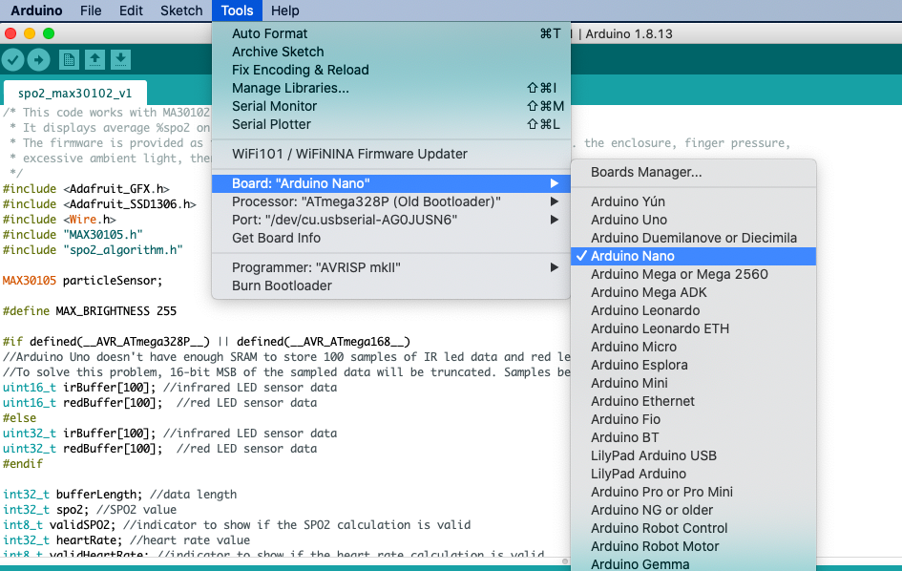

1. In the Arduino IDE, select the processor.

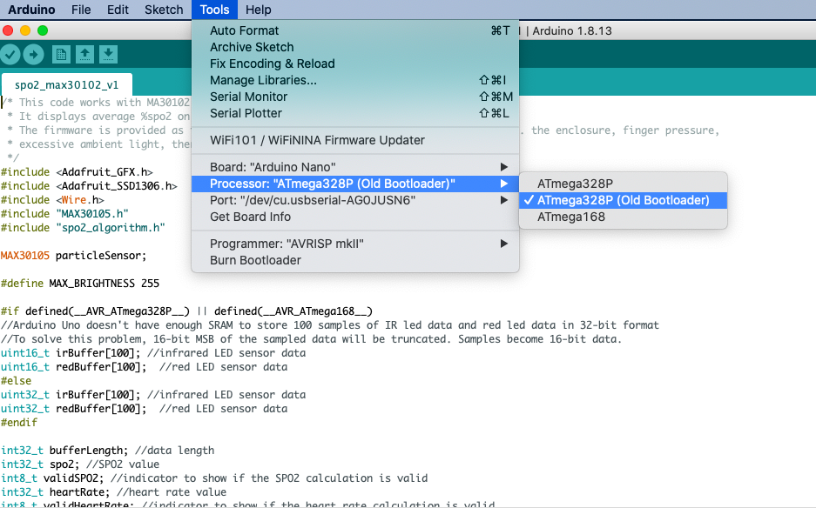

1. In the IDE, Select port where the board is connected with the PC.

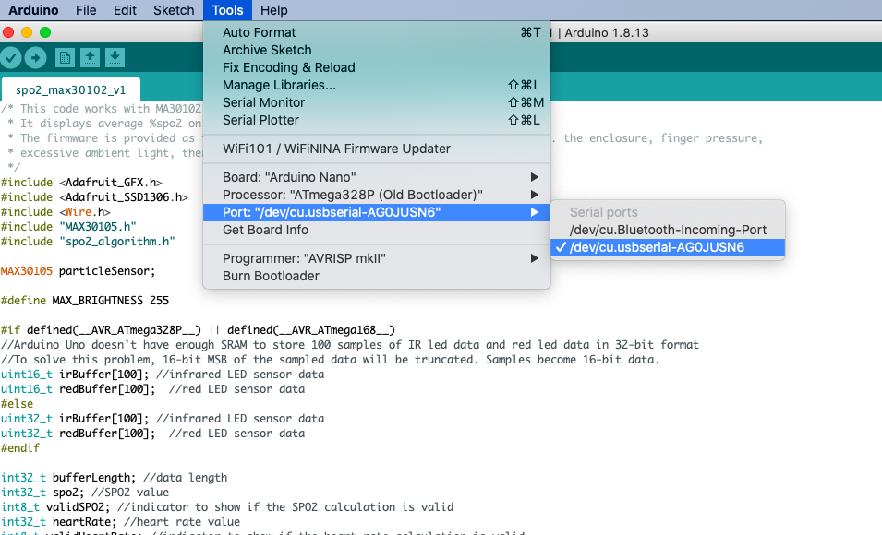

1. In the IDE, Add Library .zip files (3 .zip files) supplied alongwith.

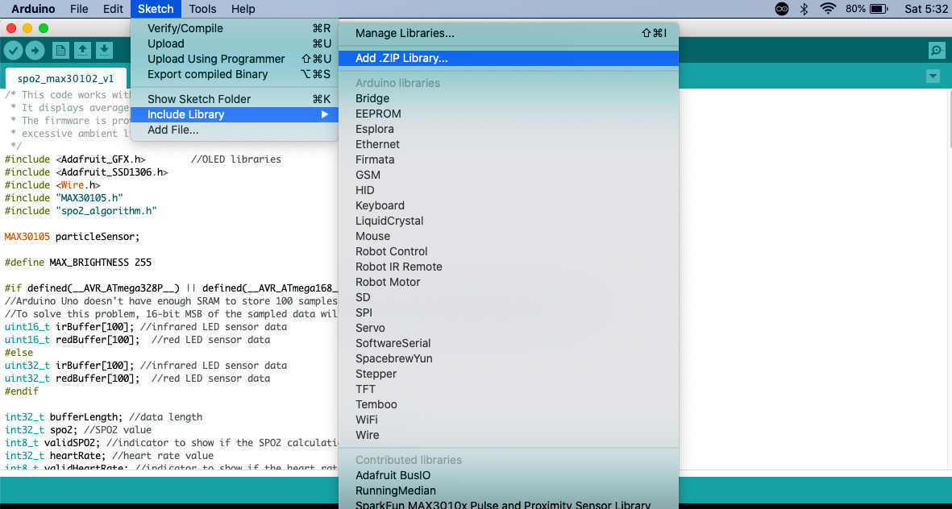

1. Open the program(.ino file) supplied herewith.

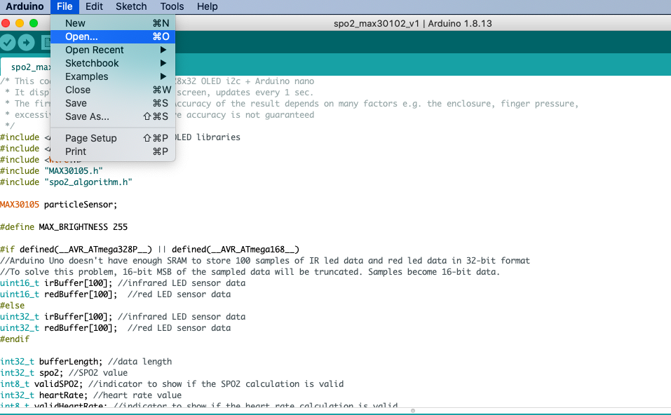

1. Flash the .ino file into the board.

